3 Level Guide - Chapter 4 – I Am Not Esther

Statement | True / False | Why/Why not?
1) Kirby is not in Wanganui. | T / F
2) The cult is called the Circle of Fellowship. | T / F |  | 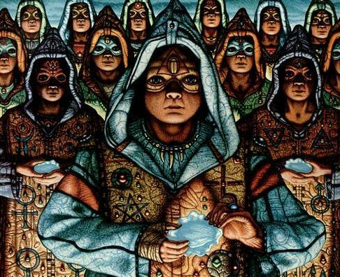
3) Kirby’s mum’s gear is hidden in the garage. | T / F
4) Miriam is a bit older than Kirby. | T / F
5) Uncle Caleb lied to the family about what happened to Miriam. | T / F
6) Kirby blames her mother for making her like a refugee. | T / F
7) Miriam’s artistic tendencies caused her to leave the family home. | T / F
8) The whole family miss Miriam. | T / F
9) Maggie becomes like a ‘limp rag doll’ because she is sick. | T / F
10) Ghosts exist. | T / F
11) Parents should leave their children crying for hours. | T / F
12) When parents leave their children, they should keep in touch. | T / F

